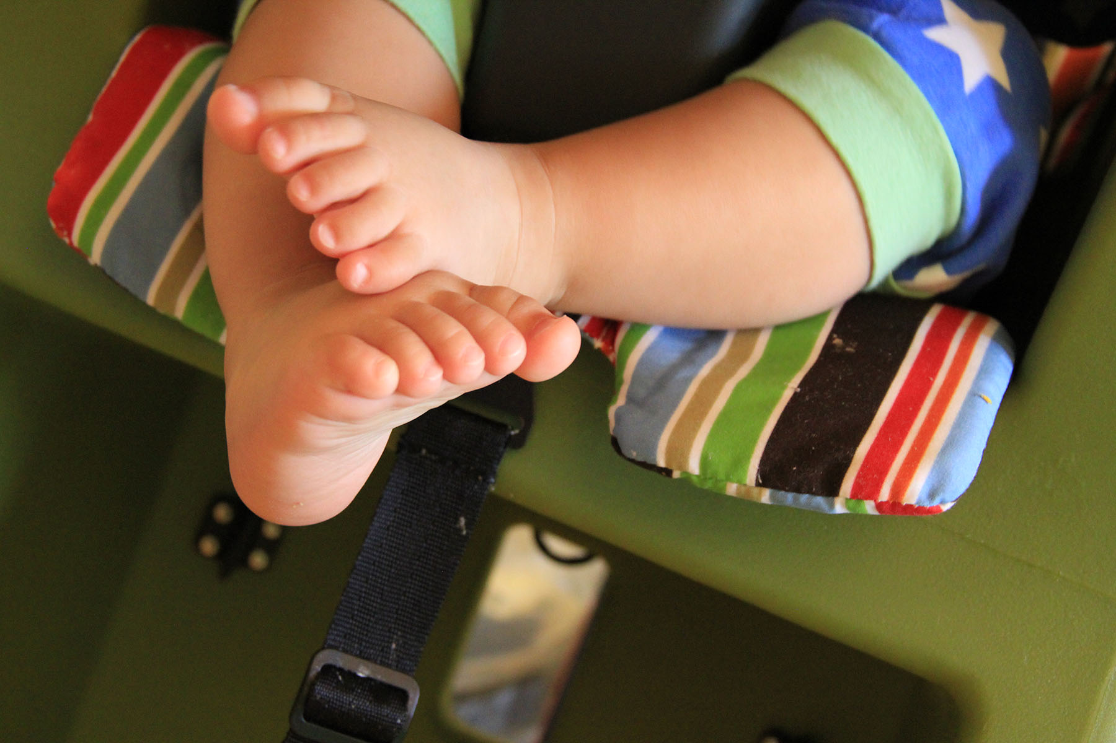

Dear BABY,

SwoodsonSays.com

Love,

________________

I hope you never

_____________

I hope you become

____________

I hope you love

________________

I hope you le66arn

**Please share your hopes for baby’s future, silly or serious, so we can save them for him to read once he is older!**

____________