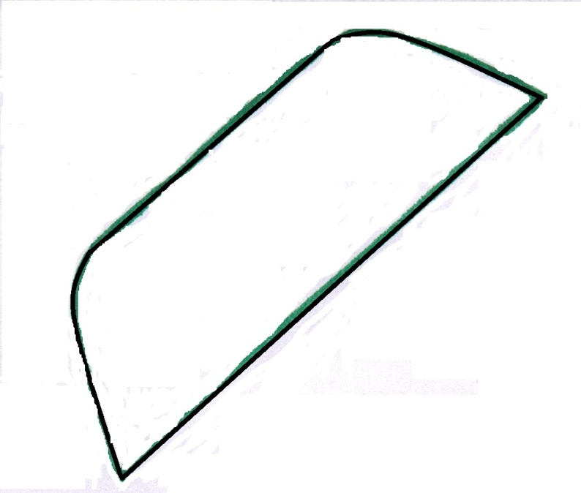

Free Camera Applique Pattern - swoodsonsays.com

